Components in React

Components are the building blocks that comprise a React application representing a part of the user interface.

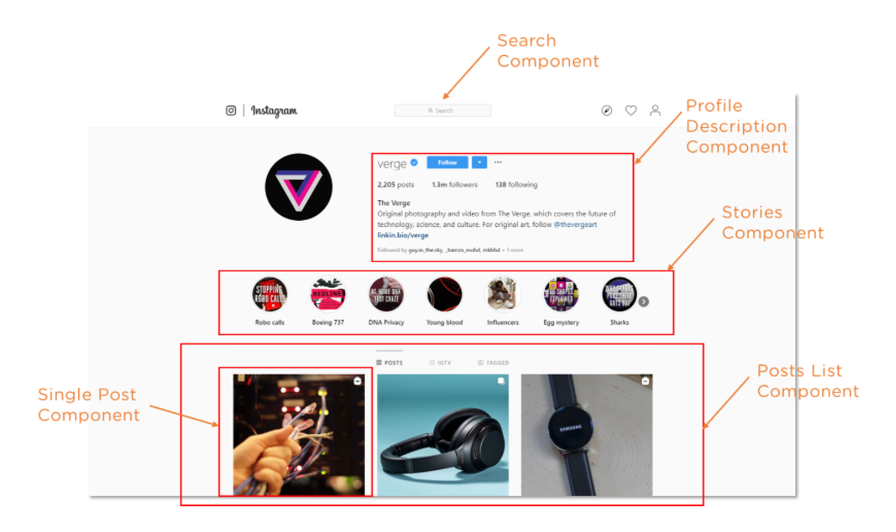

React separates the user interface into numerous components, making debugging more accessible, and each component has its own set of properties and functions.

Here are some of the features of Components -

* Re-usability - A component used in one area of the application can be reused in another area. This helps speed up the development process.
* Nested Components - A component can contain several other components.
* Render method - In its minimal form, a component must define a render method that specifies how the component renders to the DOM.
* Passing properties - A component can also receive props. These are properties passed by its parent to specify values.

Have a look at the demo for a better understanding.

**FUNCTIONAL COMPONENT**

**CLASS COMPONENT**

**IMPORT THE COMPONENTSDEMO.JS IN APP.JS**

**CALL THE CLASS COMPONENT->WHICH CALLS THE FUNCTIONAL COMPONENT AUTOMATICALLY**

**RUN THE APP**

**OUTPUT**

